**Name: ATHIRA BIJU**

**Roll No: 6**

**Batch: B**

**Date: 17/06/22**

**NETWORKING & SYSTEM ADMINISTRATION LAB**

**Experiment No.:**

**Aim**

Wireshark

**Procedure**

Create a sample shell script to run always until the system is running. We will bash while loop infinitly

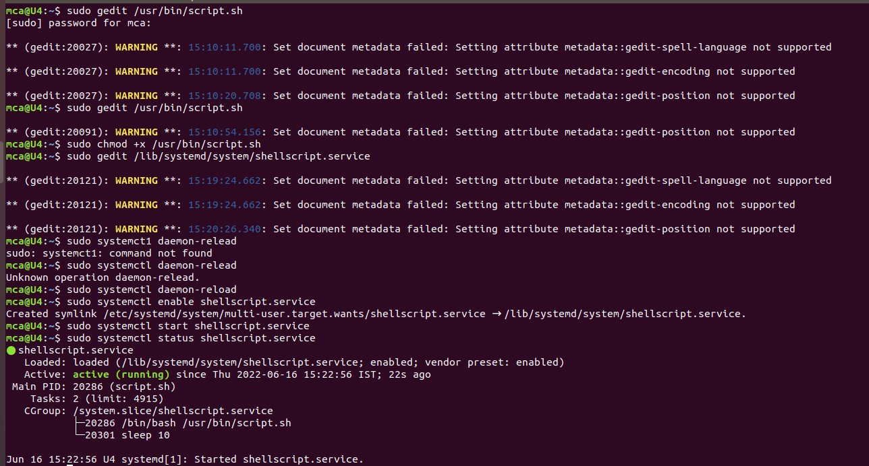

Add the following sample script

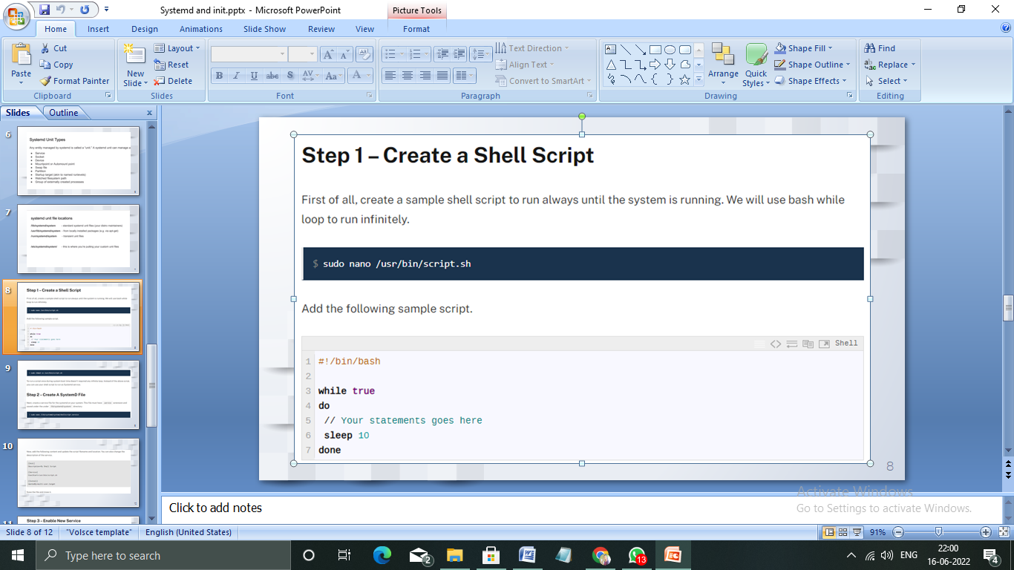

To run a script during system boot doesnot required any system loop



Create a service file for system on your system



Add the following contend and update the script file name and location.

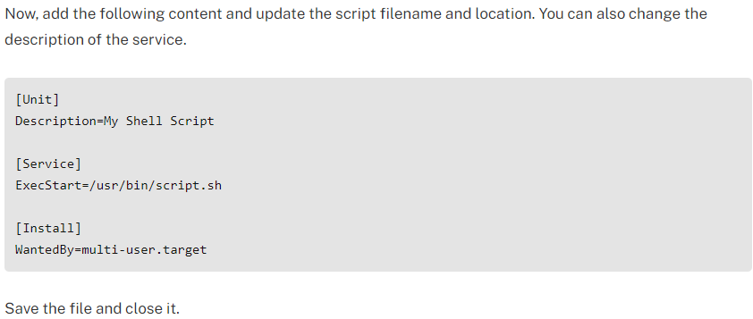

Reload the systemctl daemon to read new file



Enable the service to start on system



Verify the system is up and running as system service



Output looks :

